Is the face of public safety changing? Community activists calling to reduce police funding in favor of an increased focus on mental health would hope so. A look-back of the last 5 years of jurisdictional police budgets in the Metropolitan Washington region show a mixed bag of results.

[or] Amid calls across the nation to reduce police funding and reform public safety, jurisdictions throughout the Metropolitan Washington region have offered mixed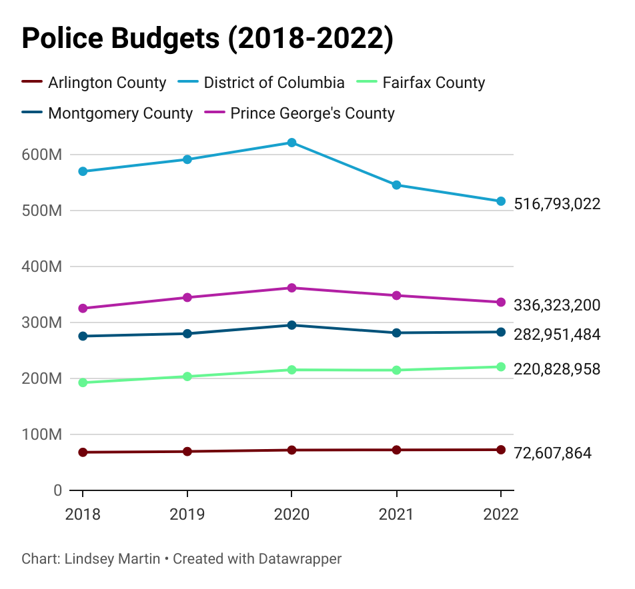 responses, a look-back at 5 years of budget data suggests.

Overall, police budgets in our region have risen over the last 5-years, with the exception of the District of Columbia’s Metropolitan Police Department, which saw a net -9.3% drop in allocations since 2018. Arlington, Montgomery and Prince George’s County Police all saw a modest budget rise of a few points. In a stark departure, however, Fairfax County Police saw a massive 14.7% budget increase since 2018.

But all jurisdictions have seen decreased funding over the last two budget cycles, indicating that perhaps calls to defund the police have had some affect on the priorities funded by jurisdictions. Calls to defund have come into immense prominence over the last two years, following the killing of George Floyd by Minneapolis Police in June 2020, just before the District of Columbia begins their annual budget process. But, calls to reform policing have been increasing in prominence since 2014, after the killing of Michael Brown by police in St. Louis, spurred the initial rise of the Black Lives Matter movement.

Alongside these calls has also been an economic crisis brought on by the COVID-19 pandemic that has constrained government budgets across the nation.

Members of the D.C. Council found themselves at odds with the Mayor’s police budget priorities this last cycle. The Mayor’s $59 million budget proposal to boost MPD staffing and a co-responder model proposal took a massive cut prior to the final budget adoption for FY 2022.

DC Councilmember James Allen, Chair of the Judiciary and Public Safety Committee says the Council’s rejection of the Mayor’s proposed funding allocation was driven by…

“___________________________________________”

It’s not enough, however, to look at the initial funding amount and assume a jurisdiction’s priorities. Take, for example, Fairfax County. The County saw a steady 5% budget growth within the police department until 2021, when it saw a less than one percent decrease in overall budget, bolstered back with an almost 3% increase in 2022.

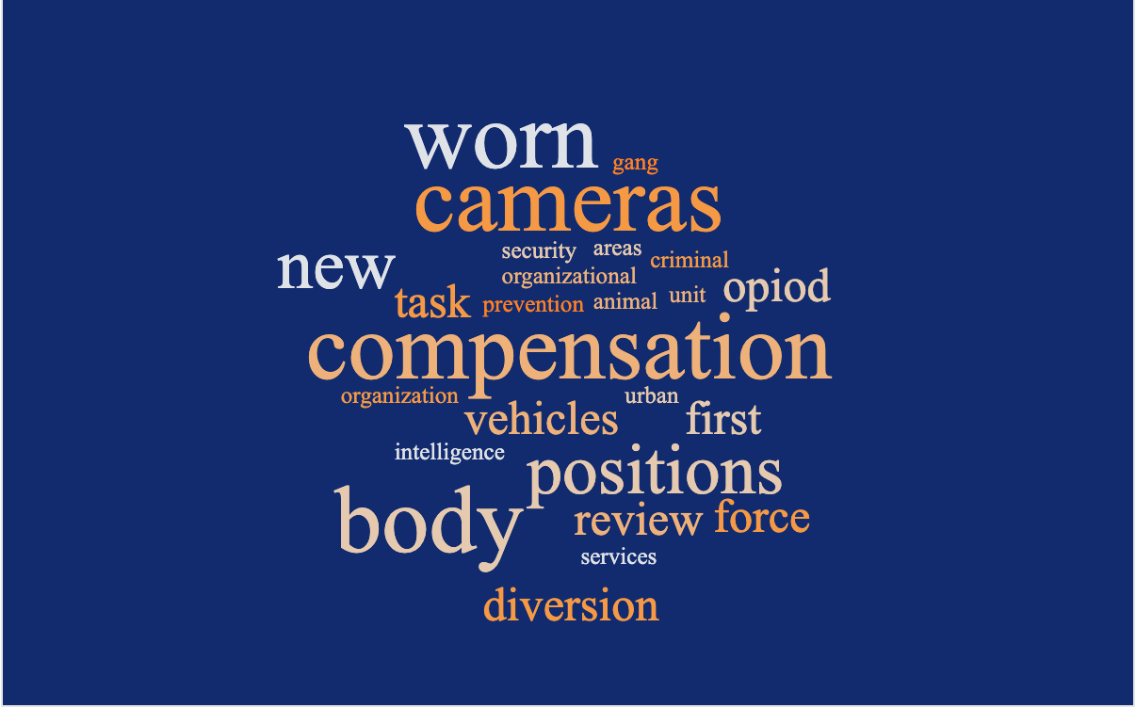

Most Cited Funding Adjustments, Fairfax County 2019-2022

A review of where that money is being directed to once allocated to the police department offers a much clearer picture.

Certainly, employee compensation and new positions received a large chunk of new funds over the years. But, a few unexpected new initiatives requiring additional funding also progressively made an appearance within the police department budget. Primarily, millions of dollars in recent years could be attributed to body worn cameras and funding to support the County’s “Diversion First” initiative, which trains officers to recognize a mental health crisis in a resident and work to divert them from jail and towards mental health resources.

An analysis of the cited items targeted with increases in the Fairfax County police budget since 2018 revealed a strong emphasis on compensation, seeing a steady 5% increase for a few years before tapering off with the onset of COVID-19. However, the implementation of body-worn cameras for all FCPD officers has driven a multi-million dollar increase for the department as well, revealing a shift in priorities for the County.

Anthony Guglielmi, Public Information Officer for the Fairfax County Police Department, states the increased funding levels can be attributed to … …,.

“_____________________________________________________________”

**FAIRFAX PD PHOTO HERE**

Fairfax County has seen its share of controversy and tragedy surrounding police actions, including the police shooting that killed unarmed county resident John Geer in his home in 2013, prompting calls for police reform and leading to the creation of the [Ad Hoc Police Practices Review Commission](https://www.fairfaxcounty.gov/policecommission/) by then Board of Supervisors Chairman Sharon Bulova in 2015.

Recent years have seen an increased focus on select police reforms, such as the set-up of the Police Civilian Review Panel, a citizen-led committees that investigates allegations of police misconduct.